**Voice Recognition Using Arduino:**

***Component Requirement:***

1. **Arduino UNO-1**
2. **HC-05(Bluetooth module)-1**
3. **l293D motor driver IC-1**
4. **DC Geared motors-2**
5. **9V Batteries with clips-2**
6. **Chasis-1**
7. **Connecting wires**

**Connection:**

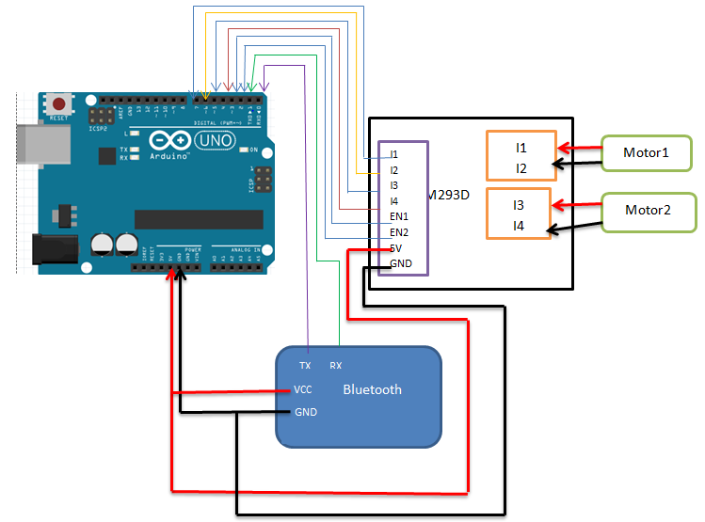

**CODE:**

**String readString;**

**int EN1=2;**

**int I1=3;**

**int I2=4;**

**int EN2=7;**

**int I3=5;**

**int I4=6;**

**int speed=600;**

**void setup() {**

**// put your setup code here, to run once:**

**Serial.begin(9600);**

**pinMode(I1,OUTPUT);**

**pinMode(I2,OUTPUT);**

**pinMode(I3,OUTPUT);**

**pinMode(I4,OUTPUT);**

**pinMode(EN1,OUTPUT);**

**pinMode(EN2,OUTPUT);**

**}**

**void loop() {**

**// put your main code here, to run repeatedly:**

**while (Serial.available())**

**{**

**delay(10);**

**analogWrite(EN1, speed);**

**analogWrite(EN2, speed);**

**char c = Serial.read();**

**if (c == ',')**

**{**

**break;**

**}**

**readString += c;**

**}**

**if (readString.length() > 0)**

**{**

**Serial.println(readString);**

**if(readString == "forward")**

**{**

**digitalWrite(I2, HIGH);**

**digitalWrite(I4, HIGH);**

**digitalWrite(I1, LOW);**

**digitalWrite(I3, LOW);**

**}**

**if(readString == "backward")**

**{**

**digitalWrite(I1, HIGH);**

**digitalWrite(I3, HIGH);**

**digitalWrite(I2, LOW);**

**digitalWrite(I4, LOW);**

**}**

**if (readString == "left")**

**{**

**digitalWrite(I1, HIGH);**

**digitalWrite(I2, LOW);**

**digitalWrite(I3, LOW);**

**digitalWrite(I4, HIGH);**

**}**

**if ( readString == "right")**

**{**

**digitalWrite(I1, LOW);**

**digitalWrite(I2, HIGH);**

**digitalWrite(I3, HIGH);**

**digitalWrite(I4, LOW);**

**}**

**if ( readString == "stop")**

**{**

**digitalWrite(I1, HIGH);**

**digitalWrite(I2, HIGH);**

**digitalWrite(I3, HIGH);**

**digitalWrite(I4, HIGH);**

**}**

**readString = "";**

**}**

**}**